Software Requirements Specification

for

KAIte
Version 0.0.6 approved
Prepared by,
Team BlackBox
COS420Fall2026
10/11/2026
Table of Contents
Table of Contents ii
Revision History iii
1. Introduction 1
1.1 Purpose 1
1.2 Document Conventions 1
1.3 Intended Audience and Reading Suggestions 1
1.4 Product Scope 1
1.5 References 1
2. Overall Description 1
2.1 Product Perspective 1
2.2 Product Functions 2
2.3 User Classes and Characteristics 2
2.4 Operating Environment 2
2.5 Design and Implementation Constraints 2
2.6 User Documentation 2
2.7 Assumptions and Dependencies 2
3. External Interface Requirements 3
3.1 User Interfaces 3
3.2 Hardware Interfaces 5
3.3 Software Interfaces 5
3.4 Communications Interfaces 5
4. System Features 5
1.1 System Feature 1 5
5. Other Nonfunctional Requirements 6
5.1 Performance Requirements 6
5.2 Safety Requirements 7
5.3 Security Requirements 7
5.4 Software Quality Attributes 7
5.5 Business Rules 7
6. Other Requirements 7

Revision History
Name | Date | Reason For Changes | Version
Initial Version | 10/02/26 | Initial Document Creation | 0.0.1
Content Addition | 10/05/26 | Reflection Conversion, Initial Requirements | 0.0.2
Content Addition | 10/06/26 | Requirements added | 0.0.3
Minor Revision | 10/07/26 | Revised Requirements | 0.0.4
Minor Revision | 10/08/26 | Revised Requirements | 0.0.5
Content Addition | 10/11/26 | Initial User Interfaces | 0.0.6
Content Addition | 10/15/26 | Revision History added, Updated multiple sections | 0.0.7

Introduction

Purpose
KAIte v1.1 is an application extension built off of the WeFlect AI reflection application with an optional testing playground for improving users’ agentic error-detection skills and history tracking progress over time through a user account integrated with the University of Maine’s internal communication platform, CollaborAITE. Further details are provided in the Product Description document.

Document Conventions
This Document was created based on the IEEE template for System Requirement
Specification Documents. Requirement prioritization is assigned individually and is not inherited by higher-level requirements.

Intended Audience and Reading Suggestions
This document is for developers, project managers, users, and testers.

Product Scope
<Provide a short description of the software being specified and its purpose, including relevant benefits, objectives, and goals. Relate the software to corporate goals or business strategies. If a separate vision and scope document is available, refer to it rather than duplicating its contents here.>

For the architecture design of KAIte, the Model-View-Controller (MVC).

References
- IEEE Computer Society, IEEE Std 830-1988: IEEE Recommended Practice for System Requirement Specification Documents, 1988.
- Team BlackBox, F26-TeamB, GitHub, 2026. [Online]. Available: https://github.com/COS420-F25/F26-TeamB

Overall Description

Product Perspective
<Describe the context and origin of the product being specified in this SRS. For example, state whether this product is a follow-on member of a product family, a replacement for certain existing systems, or a new, self-contained product. If the SRS defines a component of a larger system, relate the requirements of the larger system to the functionality of this software and identify interfaces between the two. A simple diagram that shows the major components of the overall system, subsystem interconnections, and external interfaces can be helpful.>

Product Functions
<Summarize the major functions the product must perform or must let the user perform. Details will be provided in Section 3, so only a high-level summary (such as a bullet list) is needed here. Organize the functions to make them understandable to any reader of the SRS. A picture of the major groups of related requirements and how they relate, such as a top-level data flow diagram or object class diagram, is often effective.>

User Classes and Characteristics
<Identify the various user classes that you anticipate will use this product. User classes may be differentiated based on frequency of use, subset of product functions used, technical expertise, security or privilege levels, educational level, or experience. Describe the pertinent characteristics of each user class. Certain requirements may pertain only to certain user classes. Distinguish the most important user classes for this product from those who are less important to satisfy.>

Operating Environment
<Describe the environment in which the software will operate, including the hardware platform, operating system and versions, and any other software components or applications with which it must peacefully coexist.>

Design and Implementation Constraints
<Describe any items or issues that will limit the options available to the developers. These might include: corporate or regulatory policies; hardware limitations (timing requirements, memory requirements); interfaces to other applications; specific technologies, tools, and databases to be used; parallel operations; language requirements; communications protocols; security considerations; design conventions or programming standards (for example, if the customer’s organization will be responsible for maintaining the delivered software).>

User Documentation
<List the user documentation components (such as user manuals, on-line help, and tutorials) that will be delivered along with the software. Identify any known user documentation delivery formats or standards.>

Assumptions and Dependencies
<List any assumed factors (as opposed to known facts) that could affect the requirements stated in the SRS. These could include third-party or commercial components that you plan to use, issues around the development or operating environment, or constraints. The project could be affected if these assumptions are incorrect, are not shared, or change. Also identify any dependencies the project has on external factors, such as software components that you intend to reuse from another project, unless they are already documented elsewhere (for example, in the vision and scope document or the project plan).>

External Interface Requirements

User Interfaces
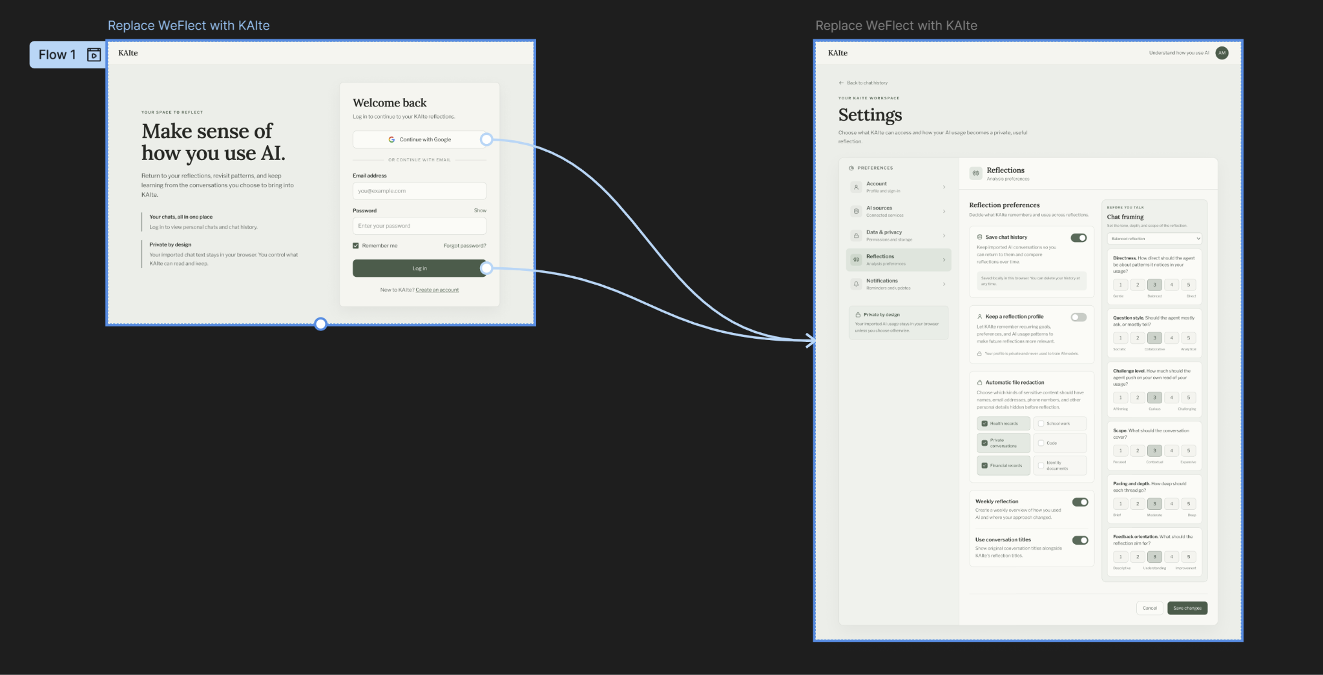

- Login to access settings:
  - Primary purpose: Give users the ability to change settings only when logged in.
  - Fields: Login with gmail, login with email+password.
  - Actions: Login, create account, adjust settings such as framing choice, what KAIte saves.

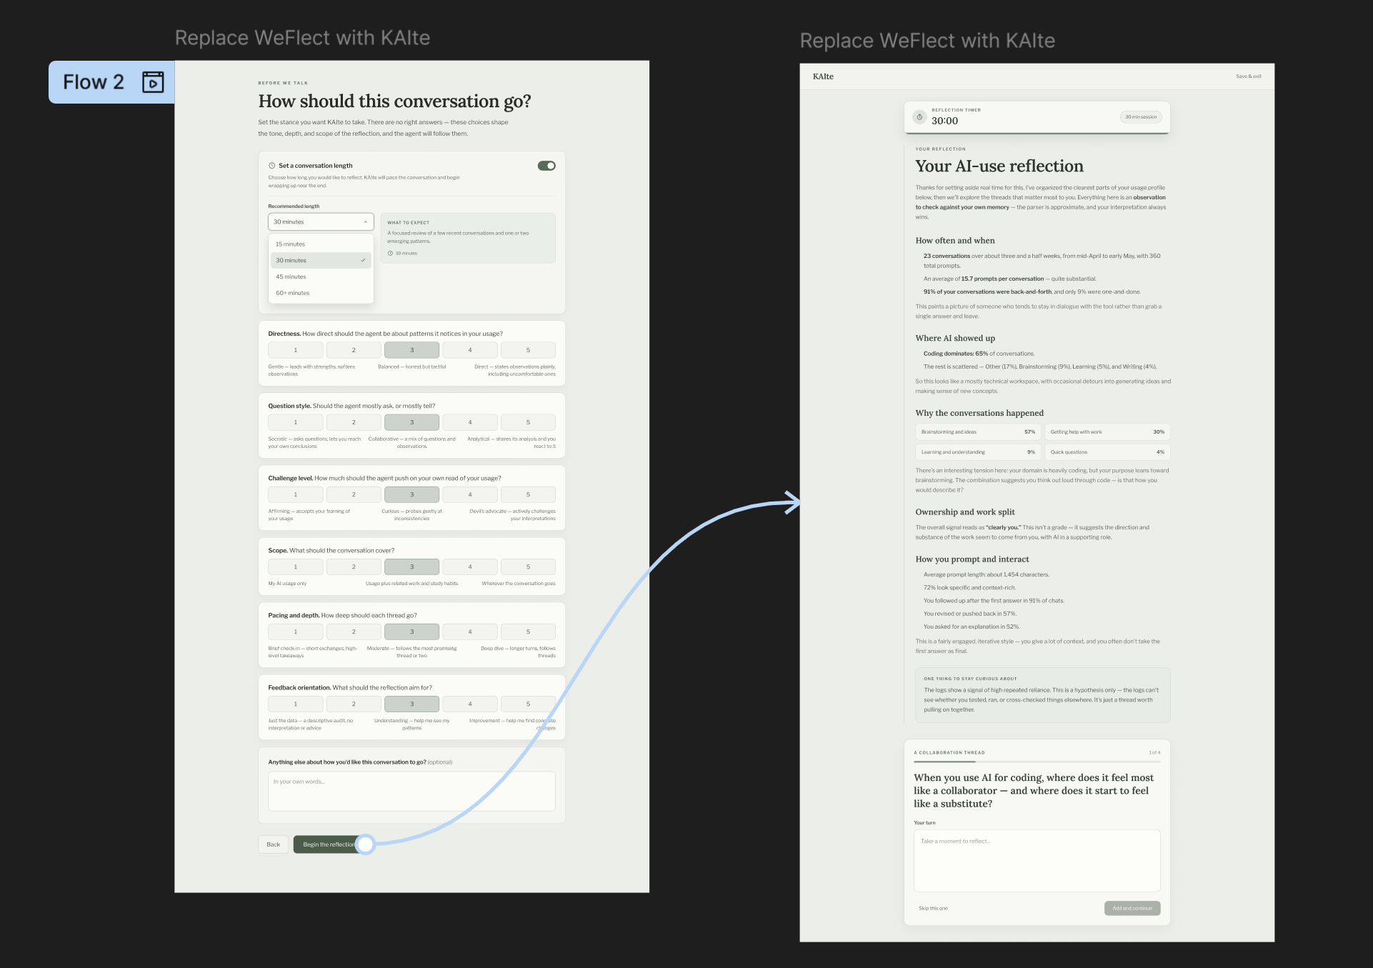

- Ability to set a conversation timer:
  - Primary purpose: allows users to set a time limit for conversation with varying scope.
  - Features: Framing choices, timer length, user input.
  - Actions: Set timer, set framing choices’ scale, reflection conversation.

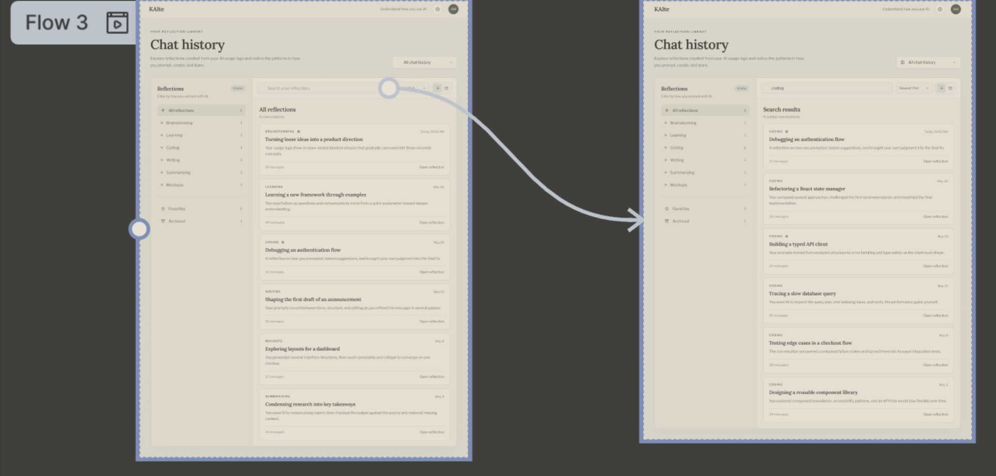

- Login to access settings:
  - Primary Purpose: Allow users to search and filter reflection conversation history.
  - Features: Conversation search bar, conversation filters, list of saved conversations.
  - Actions: Search conversation history based on keywords, filter conversation history to organize.

Hardware Interfaces
<Describe the logical and physical characteristics of each interface between the software product and the hardware components of the system. This may include the supported device types, the nature of the data and control interactions between the software and the hardware, and communication protocols to be used.>

Software Interfaces
<Describe the connections between this product and other specific software components (name and version), including databases, operating systems, tools, libraries, and integrated commercial components. Identify the data items or messages coming into the system and going out and describe the purpose of each. Describe the services needed and the nature of communications. Refer to documents that describe detailed application programming interface protocols. Identify data that will be shared across software components. If the data sharing mechanism must be implemented in a specific way (for example, use of a global data area in a multitasking operating system), specify this as an implementation constraint.>

Communications Interfaces
<Describe the requirements associated with any communications functions required by this product, including e-mail, web browser, network server communications protocols, electronic forms, and so on. Define any pertinent message formatting. Identify any communication standards that will be used, such as FTP or HTTP. Specify any communication security or encryption issues, data transfer rates, and synchronization mechanisms.>

System Features
<This template illustrates organizing the functional requirements for the product by system features, the major services provided by the product. You may prefer to organize this section by use case, mode of operation, user class, object class, functional hierarchy, or combinations of these, whatever makes the most logical sense for your product.>

System Feature 1
<Don’t really say “System Feature 1.” State the feature name in just a few words.>
4.1.1 Description and Priority
<Provide a short description of the feature and indicate whether it is of High, Medium, or Low priority. You could also include specific priority component ratings, such as benefit, penalty, cost, and risk (each rated on a relative scale from a low of 1 to a high of 9).>
4.1.2 Stimulus/Response Sequences
<List the sequences of user actions and system responses that stimulate the behavior defined for this feature. These will correspond to the dialog elements associated with use cases.>
4.1.3 Functional Requirements
REQ-1: The system shall allow the user to upload JSON conversation logs from Chat GPT, Gemini, and Claude.
REQ-2: The system shall identify the user’s primary AI usage categories from a list including brainstorming, coding, getting help, and more TBD.
REQ-3: The system shall have a reflection agent ask the user about what they think the advantages and drawbacks of the AI usage being analyzed are.
REQ-4: The system shall allow the user to customize how long they want the reflection conversation to run before it begins, such as a 15-minute conversation providing a few questions to think about or an hour-long one to identify deeper usage patterns.
REQ-5: The system shall allow the user to customize how accepting the reflection agent is of user responses that fail to answer agent questions.
REQ-6: The system shall allow the user to provide additional instructions to the reflection agent before the conversation starts.
REQ-7: The system shall provide a summary of the conversation’s findings once the user ends the conversation.
REQ-8: The system shall allow the user to download the conversation summaries.
REQ-9: The system shall give the user the option of having prior findings included for consideration in new reflection conversations.
REQ-10: The system shall allow the user to upload pdfs, docx, and json files so the agent can view them during conversation.
REQ-11: The system shall allow the registered user to re-read previous conversations with the reflection agent.
REQ-12: The system shall allow the user to search previous chats with agents by keywords.
REQ-13: The system shall allow the user to set options for what sensitive information the agent can access.
REQ-14: The system shall ask the user guiding questions from past conversations the user to curate how the agent will direct the conversation.
REQ-15: The system shall allow the user to edit previous summaries on generated agent conversations.
REQ-16: The system shall ask the user follow-up questions the next time they use the system after their previous conversation to encourage further reflection.
REQ-17: The system shall allow the user to sign in or register to access their personal chats and saved settings.

Other Nonfunctional Requirements

Performance Requirements
NON-REQ-1: The system shall load the main application page within 3 seconds at least 90% of the time.
NON-REQ-2: The system shall display saved AI use history within 3 seconds of the user’s request 99.99% of the time.

Safety Requirements
NON-REQ-3: The system shall label AI generated content for the user.

Security Requirements
NON-REQ-4: The system shall encrypt stored user info and saved AI chat history.
NON-REQ-5: The system shall not display a user's saved AI chat history to other users.
NONREQ-8: The system shall automatically log a user out after 30 minutes without user interaction.

Software Quality Attributes
NON-REQ-6: The system shall allow a new user to access main features, including starting a reflection conversation, viewing previous chats, and accessing account settings, from the main page within three clicks.
NON-REQ-7: The system shall require user confirmation before deleting or overwriting saved chat history.
NON-REQ-9: The system shall support the latest versions of Google Chrome, Microsoft Edge, and Firefox, within 30 days of each browser version’s official release.
NON-REQ-10: The system shall display an error message within 3 seconds of determining a user action cannot be completed, 99.99% of the time.

Business Rules
<List any operating principles about the product, such as which individuals or roles can perform which functions under specific circumstances. These are not functional requirements in themselves, but they may imply certain functional requirements to enforce the rules.>

6. Other Requirements
<Define any other requirements not covered elsewhere in the SRS. This might include database requirements, internationalization requirements, legal requirements, reuse objectives for the project, and so on. Add any new sections that are pertinent to the project.>

Appendix A: Glossary
- Authorized user: A user who has a verified CollaborAITE account, typically a student
- CollaborAITE: University of Maine’s internal communication platform
- KAIte: (pronounced: kīte) Team BlackBox’s application
- SRS: Software Requirements Specification
- Team BlackBox: The Company Name
- UI (User interface): Visual elements as a guide for what users would interact with.
- User: An individual that would interact with the application.
- WeFlect: An AI Use and Collaboration Reflection Agent built in University of Maine’s YESS Lab where users reflect on their AI usage logs.
Appendix B: Analysis Models
<Optionally, include any pertinent analysis models, such as data flow diagrams, class diagrams, state-transition diagrams, or entity-relationship diagrams.>
Appendix C: To Be Determined List
<Collect a numbered list of the TBD (to be determined) references that remain in the SRS so they can be tracked to closure.>

